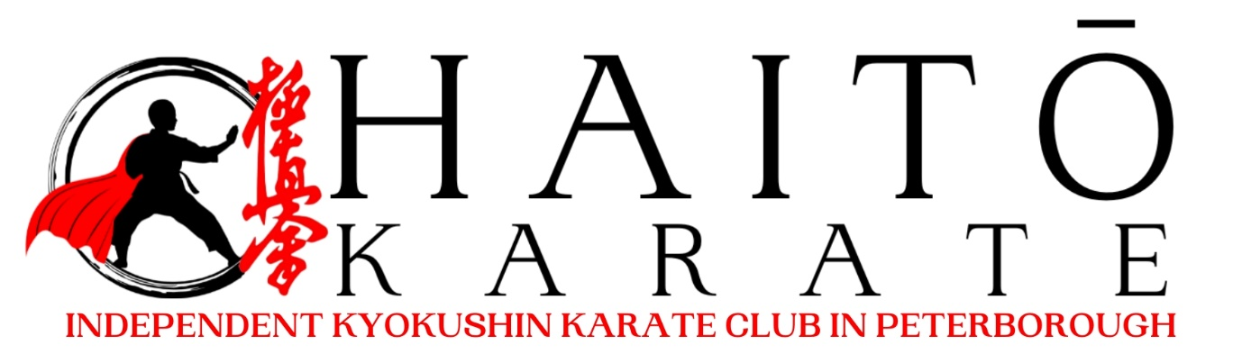

KIDS (5-9 YEARS OLD) AND JUNIORS (10-16 YEARS OLD) NOVICE TOURNAMENT RULES

Version 2.0 – Gabija Kalinauskaite
Last updated: 20/03/2026
Rules for Kids and Juniors Karate Competitions Using the Kyokushin Knockdown System
ENTRIES
- The following rules are for “semi-contact” HAITO Karate NOVICE TOURNAMENT Kids and Junior matches.
- These rules apply to male and female competitors aged over 5 to under 16 years old.
- Participants must have a minimum of 3 months of martial arts experience, not higher than the 1st KYU in the Kyokushin Karate belt system and have not competed in more than 3 national/international tournaments.
- Members of other associations who wish to compete are allowed to participate, need to sign a disclaimer stating they have a minimum of 3 months of martial arts experience, not higher than the 1st KYU and have not competed in more than 3 national/international tournaments.
- Participants must hold a minimum grade of 10th kyu unless they have previous experience in another martial art, which their instructor has considered when entering.
- Competitors may be examined by a medical doctor or first aider prior to competing to ensure their physical condition is suitable. A doctor or first aider may use their discretion to withdraw a competitor at any time.
- Organizers reserve the right to stop an individual from competing if they deem it disproportionately unsafe for the person to participate.
- HAITO Karate or its appointed officers or officials accept no responsibility for any accident or injury incurred during the tournament.

GENERAL RULES ON SAFETY
- If required, the medical examination may take place either the day before or on the day of the competition. In some cases, a doctor's medical certificate obtained prior to the event may be accepted.
- The competitor’s weight may be verified the day before or on the day of the competition, as specified in the event invitation. If a competitor fails to meet the requirements for a specific weight category, the organizers will decide whether they can be placed in a different category.
- Each contestant must wear a clean white GI (kimono) with sleeves and trousers fully extended (not rolled up).
- A red or white belt, tag, vest or helmet may be used to distinguish the fighters.
- Fingernails and toenails must be trimmed short.
- Long hair must be tied back with a soft band, and hard hair clips are not allowed.
- Standard white elasticated shin and instep pads are mandatory.
- Male competitors must wear a groin protector under their GI (kimono) pants.
- Female competitors must wear a suitable chest protector under the vest if needed.
- All competitors must wear an “open-faced” head guard.
- Contestants must use suitable fist-mitts, as agreed by the organizers.
- Gum shields are recommended, and a custom mouthguard is required for those with braces.
- The scoring threshold for strikes to the legs and body is lower than that for adult competitors.
- Only light contact with the head guard is allowed with specified kicks, which may score a Wazari.

MATCH AREA
- The fighting area will be a square measuring 5 x 5 meters, with a 1-meter safety zone surrounding it.
- Contestant placement, along with the positioning of the referee, judges, and arbitrator, will follow standard karate match guidelines.
- The contest area must be covered with matting at least 20mm thick, suitable for semi-contact fighting.
- Officials Team:
- Option 1: 1 main referee, 4 corner judges, and 1 arbitrator.
- Option 2: 1 main referee, and 2 judges, one of whom also serves as the arbitrator.
- At the end of each round, every official has 1 vote. A draw may be declared unless otherwise directed.
- In a 5-person team, the arbitrator does not vote but ensures that the match follows the rules.
- In a 3-person team, the arbitrator will also vote on the match outcome if needed.
- Table Officials: 1 timekeeper and 1 organizer
CATEGORIES
- Categories Male/Female.
- These will be separated into ages: 5-7 (U8), 8-9 (U10), 10-11 (U12), 12-13 (U14) & 14-15 (U16) years old.
- Each age will be subject to division into weights at the discretion of the organisers.

DURATION OF THE MATCH
- Competition is organized in order to gain experience for all fighters and organizers, referees and judges will do their best to provide opportunity to fight all 3 rounds, unless it is deemed unsafe.
- For ages 5-7 and 8-9 each round (3 rounds in total) lasts 1min (60 sec) unless another duration has previously been agreed, with 30sec break.
- For ages 10-11, 12-13 and 14-15 each round (3 rounds in total) lasts 1.5min (90sec) unless another duration has previously been agreed, with 30sec break.
- All age groups compete in all 3 rounds with the same opponent. The decision is given only after all 3 rounds are finished, unless one of the competitors have given up or referee and judges decide it is not safe to continue the round.

CRITERIA FOR DECISION/SCORE
- A contestant wins the round by scoring an Ippon (full point) to the body or legs.
- Contestants can score multiple Wazari’s during each round. Wazari’s do not move to the next round.
- No Ippon is allowed to the head.
- At the end of a round, if one contestant has a score and the other has none, the one with the score wins that round. Winner is announced after all 3 rounds are completed with the one who won 2 out of 3 rounds.
- An Ippon is given if an opponent is disabled or seriously affected by a legal move for 5 or more seconds.
- A Wazari is given if an opponent is affected by a technique for less than 5 seconds.
- An Ippon or Wazari can be given if an opponent refuses to continue the fight when instructed.
- A serious violation of the rules, either by improper technique or behaviour, will result in disqualification.
- Officials can make a decision based on a contestant's power, techniques, tactics, and fighting spirit.

LEGAL TECHNIQUES
- Punches with the closed fist to the body.
- Round or direct elbow strikes to the body.
- Blocking a strike with any part of the hand or arm.
- Kicking to the opponent's thighs with your shin/instep.
- Kicking with any part of the leg to the body.
- Only controlled Jodan Mawashi Geri’s (Round Kicks), Jodan Uchi Haisoku Geri’s (Inverted Round Kicks) and Ushiro Kakegeri Jodan Chusoku’s (Spinning Back Kick with a Ball of the Foot) are allowed to the side of the head guard.
- Blocking your opponents’ techniques with your leg/foot.
- Un-sustained push to the opponent’s body with one or both arms to create space for a follow-up technique.

PROHIBITED TECHNIQUES
- Attacks to the opponent’s head, face, or neck with the hand, fist, or any part of the arm.
- Kicks to the groin.
- Head-butts or thrusts.
- Direct kicks to the knee or hip joints.
- Grabbing any part of the opponent’s body or clothing.
- Any strikes to the spine.
- Striking a “downed” opponent.
- Attacking from the floor.
- Sustained pushing or holding of an opponent's body or limbs.
- Failing to obey the referee’s instructions during the bout.
- Any other techniques or actions that the referee deems improper or unfair.
- Sweeps.

WARNINGS/PENALTIES
- Chui: An informal warning with no penalty.
- Chui Ichi: The first level of official warnings.
- Chui Ni: The second level of official warnings.
- Genten Ichi: A warning that should be considered when making a decision.
- Genten Ni: If the opponent has no score, this counts as a wazari against them and can cancel out a score given to the same competitor.
- Genten San: A serious breach resulting in disqualification. In extreme cases, it can lead to a "Shikaku", which disqualifies the contestant from the event.
- A contestant will be disqualified if they are not in the fighting area within a specified time (1 minute). The bout will then be automatically awarded to the opponent.
For any penalty beyond a Chui Ichi, all officials must be involved in the decision.

TERMINOLOGY USED BY REFEREE’S AT KARATE TOURNAMENTS
Proceeding with the bout:
- Rei (bow)
- Shomen ni rei (bow to the officials)
- Shushin ni rei (bow to the referee)
- Otagai ni rei (bow to each other)
- Kamaete (assume your fighting stance)
- Hajime (start the bout)
During the bout:
- Yame (stop)
- Kamaete (assume your fighting stance)
- Zoko (continue)
- Shiro nakai (white sash wearer enters the area)
- Aka nakai (red sash wearer enters the area)
- Atoshi baraku (30 seconds remaining)
Fouls as previously described:
- Chui (point to the feet)
- Chui-ichi (point to the waist)
- Genten-ichi (point to the chest)
- Genten-ni (point to the face)
- Hansoku/Shikkaku (point to the face and then off the tatami)
- Jogai ((leaving the area) 3 consecutive infringements will lead to a formal penalty)
The referee will declare who has fouled, the infringement and the penalty. For instance: Aka, punching to the face, genten ichi.

EXAMPLES OD THE PROTECTIVE EQUIPMENT
